Exercise 1: Topic 1 (Introduction to Statistics)
2025/2026 – SEM II
QUESTION 1
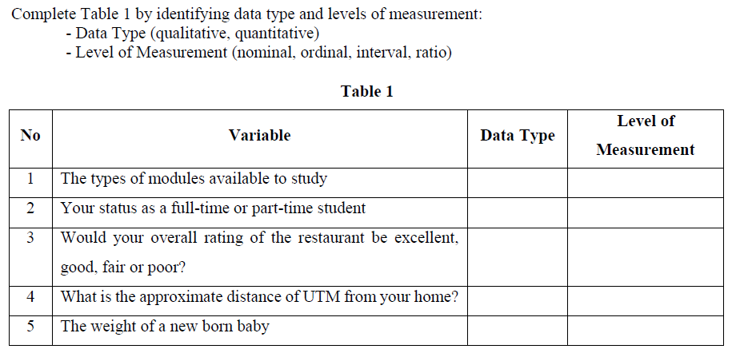

QUESTION 2
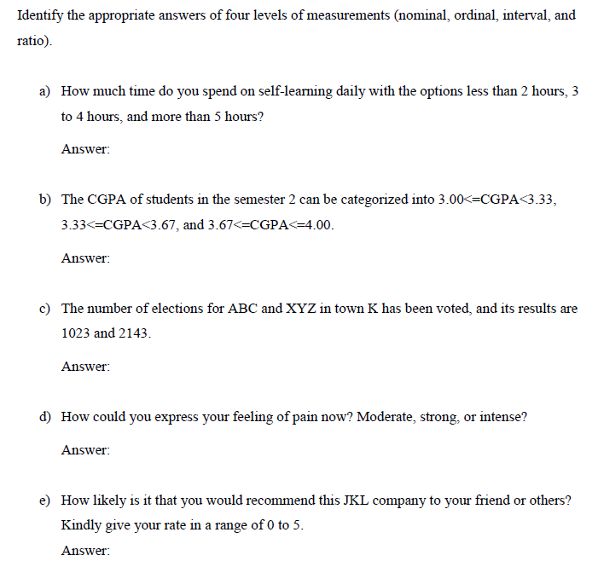
QUESTION 3
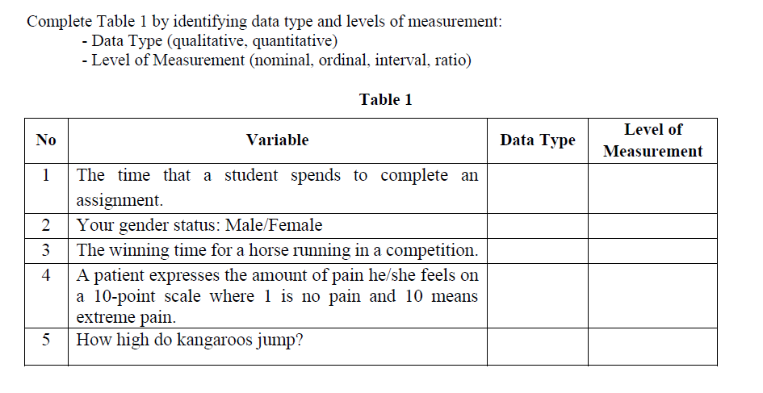
QUESTION 4
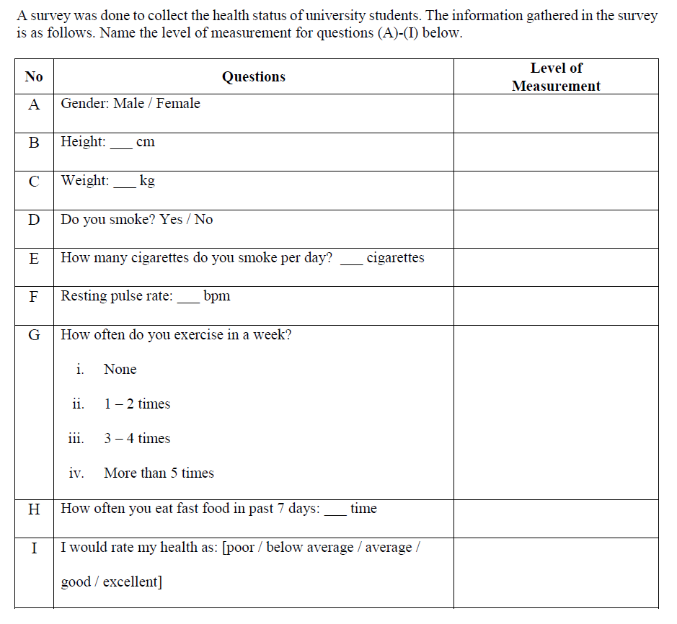

QUESTION 5
